**1. Calculate Addition, Subtraction, Multiplication, and Division from 2 numbers provided by user input.**

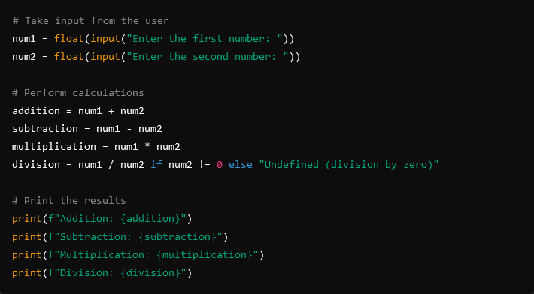

**Output:**

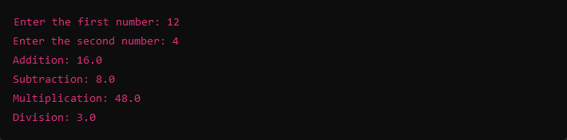

**2. Write a Program for Simple Interest.**

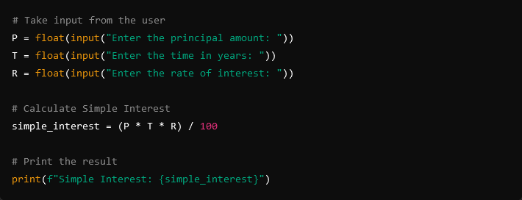

**Output:**

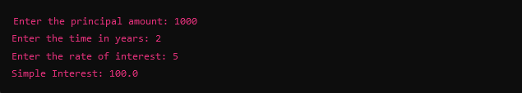

**3. Create a Marksheet for 5 subjects and calculate total, average, and grade with if-else.**

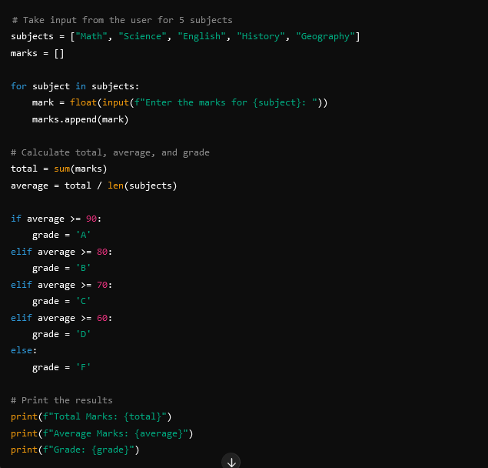

**Output:**

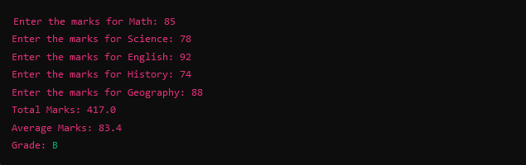

**4. Write a program to add employee names in a list EMPNAME and perform add, remove, and append methods.**

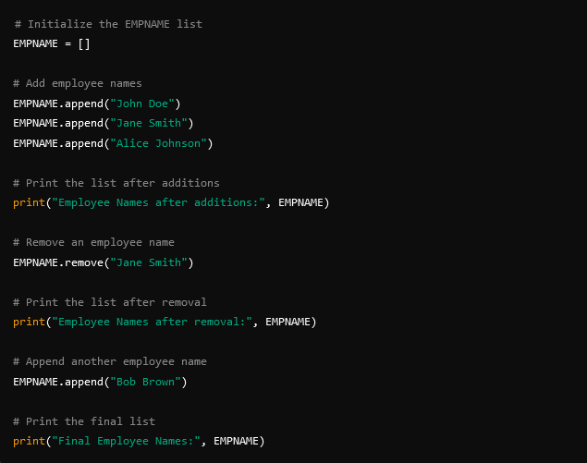

**Output:**

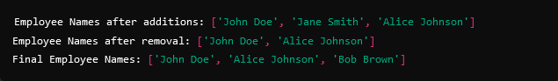

**5. Print 1 to 10 and 10 to 1 with a for loop.**

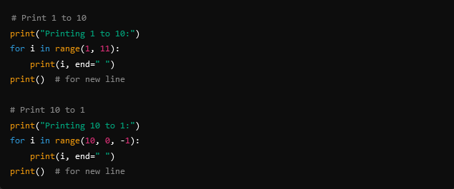

**Output:**

